Why Choose the BBA?

- The BBA will provide an opportunity for children of township residents to learn and play baseball.
- The BBA will promote a league where equal playing time for all participants is stressed and exposure to infield and outfield positions is encouraged. Minimum playing time, in terms of innings played will be established for all age groups and must be adhered to by all managers.
- The BBA is the only youth Bethel Park Youth Baseball Organization consisting of 100% Bethel Park Residence and youth. We do not bring in youth from other communities to fill our rosters.

Contact Us:

Bethel Baseball Association
WWW.BETHELBASEBALL.ORG
PO Box 241
Bethel Park, PA 15102
Email: infobethelbaseball@gmail.com



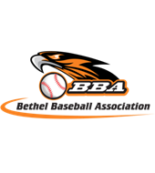
Visit us at:

WWW.BETHELBASEBALL.ORG

Objective:

The objective of the organization shall be to implant firmly in the youth of the community the ideals of good sportsmanship, honesty, loyalty, courage, and reverence, so that they may be finer, stronger, and happier and will grow to be good, clean, healthy adults. The supervisors shall bear in mind that the attainment of exceptional athletic skill or the winning of games is secondary to the molding of the future men and women.

Fundraisers & Field Improvements

While the BBA is focused on the youth of Bethel Park, we understand the need to improve our fields and parks for the future generations to come. The BBA has implemented several fundraising plans to get our fields in a playable and safe condition, provide new equipment and jerseys for the youth as well as larger projects that will benefit the future of baseball in the community.

In 2016, the BBA fundraised in the form of a Pirate Tickets Lottery and a Comedy Night. All of which generated funds and we plan to continue these fundraisers to put the funds back into the fields. With the funds, we plan to purchased (2) field maintenance vehicles, a fence for the Freshman Baseball Field, as well as field improvements to Lions, Oak Tree and Park Ave.

Maintenance Vehicles
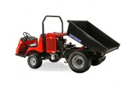

Removable Field Fence

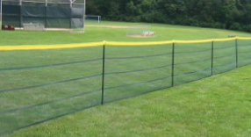

Lions Improvements

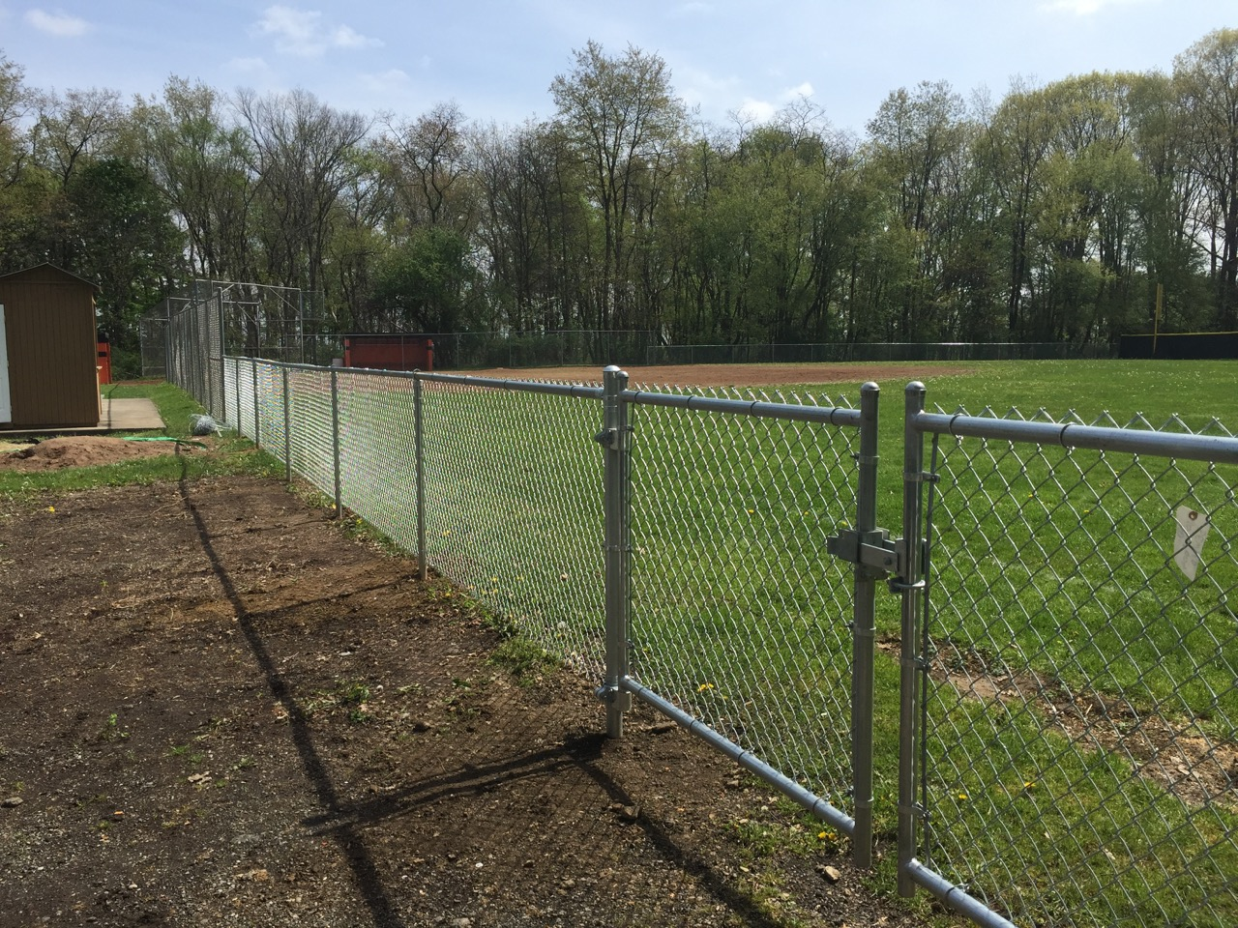
BBA offers Spring, Summer and Fall Baseball for all ages!
Spring 2017 Sign-Ups begin
February 1st. Visit www.bethelbaseball.org
to sign your child up.

Leagues and Ages w/ Dates

T-Ball – Ages 4 to 6
Minors – Ages 7 to 8
Junior –Ages 9 to 10
Senior – Ages 11 to 12
Pony – Ages 13 to 14
Colt – Ages 15 to 17
Legion – Ages 16 to 19

